EXP. NO: 10
PERFORMANCE ANALYSIS OF FM SYSTEM UNDER GAUSSIAN WHITE NOISE USING MATLAB
Objectives:
1. To generate a Frequency Modulated (FM) signal in MATLAB using the specified carrier and
message signal parameters.
PROGRAMMING CODE:
clc;
clear;
close all;

% Given Parameters
Am = 1; % Message signal amplitude
Ac = 2; % Carrier signal amplitude
fm = 100; % Message frequency in Hz
fc = 1000; % Carrier frequency in Hz
kf = 500; % Frequency sensitivity in Hz/V

% Sampling Parameters
fs = 10000; % Sampling frequency in Hz
T = 0.05; % Duration in seconds
t = 0:1/fs:T-1/fs;

% Generate Message Signal
m = Am*cos(2*pi*fm*t);

% Generate Carrier Signal
c = Ac*cos(2*pi*fc*t);

% Calculate Frequency Deviation
delta_f = kf*Am;

% Calculate Modulation Index
beta = delta_f/fm;

% Generate FM Signal
s = Ac*cos(2*pi*fc*t + beta*sin(2*pi*fm*t));

% Display Results
fprintf('Carrier Frequency = %.2f Hz\n',fc);
fprintf('Message Frequency = %.2f Hz\n',fm);
fprintf('Frequency Deviation = %.2f Hz\n',delta_f);
fprintf('FM Modulation Index = %.2f\n',beta);

% Plot Signals
figure;

subplot(3,1,1);
plot(t,m);
title('Message Signal');
xlabel('Time (s)');
ylabel('Amplitude');
grid on;

subplot(3,1,2);
plot(t,c);
title('Carrier Signal');
xlabel('Time (s)');
ylabel('Amplitude');
grid on;

subplot(3,1,3);
plot(t,s);
title('Frequency Modulated (FM) Signal');
xlabel('Time (s)');
ylabel('Amplitude');
grid on;
OUTPUTS:
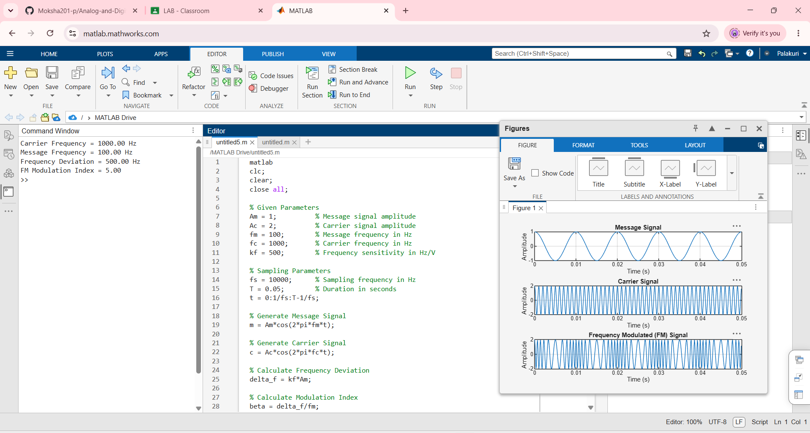
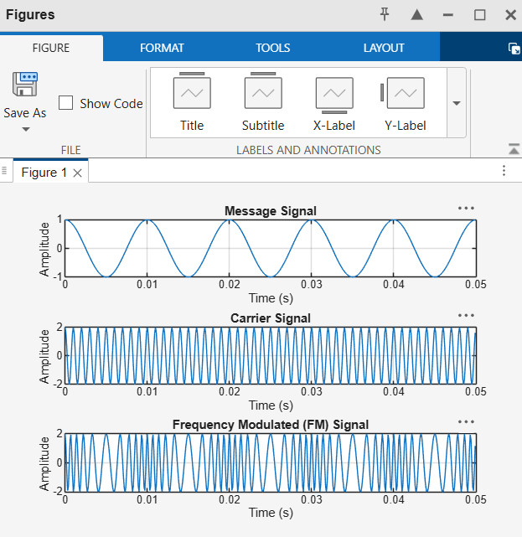
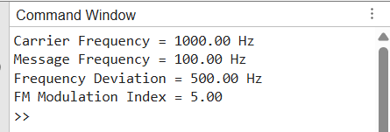

OBJECTIVE:
2. To introduce Additive White Gaussian Noise (AWGN) into the generated FM signal and simulate the effect of a noisy communication channel using MATLAB.
PROGRAMMING CODE:
clc;
clear;
close all;

% Given Parameters
Am = 1; % Message signal amplitude
Ac = 2; % Carrier amplitude
fm = 100; % Message frequency in Hz
fc = 1000; % Carrier frequency in Hz
kf = 500; % Frequency sensitivity in Hz/V
SNR = 10; % Signal-to-Noise Ratio in dB

% Sampling Parameters
fs = 10000; % Sampling frequency in Hz
T = 0.05; % Duration in seconds
t = 0:1/fs:T-1/fs;

% Generate Message Signal
m = Am*cos(2*pi*fm*t);

% Calculate FM Parameters
delta_f = kf*Am;
beta = delta_f/fm;

% Generate FM Signal
s = Ac*cos(2*pi*fc*t + beta*sin(2*pi*fm*t));

% Calculate Signal Power
signal_power = mean(s.^2);

% Generate AWGN
noise_power = signal_power/(10^(SNR/10));
noise = sqrt(noise_power)*randn(size(s));

% Received FM Signal
r = s + noise;

% Calculate Actual SNR
measured_SNR = 10*log10(mean(s.^2)/mean(noise.^2));

% Display Results
fprintf('Carrier Frequency = %.2f Hz\n',fc);
fprintf('Message Frequency = %.2f Hz\n',fm);
fprintf('Frequency Deviation = %.2f Hz\n',delta_f);
fprintf('Modulation Index = %.2f\n',beta);
fprintf('Specified SNR = %.2f dB\n',SNR);
fprintf('Measured SNR = %.2f dB\n',measured_SNR);

% Plot Signals
figure;

subplot(4,1,1);
plot(t,m);
title('Original Message Signal');
xlabel('Time (s)');
ylabel('Amplitude');
grid on;

subplot(4,1,2);
plot(t,s);
title('Generated FM Signal');
xlabel('Time (s)');
ylabel('Amplitude');
grid on;

subplot(4,1,3);
plot(t,noise);
title('Additive White Gaussian Noise');
xlabel('Time (s)');
ylabel('Amplitude');
grid on;

subplot(4,1,4);
plot(t,r);
title(['Received FM Signal with AWGN (SNR = ',num2str(SNR),' dB)']);
xlabel('Time (s)');
ylabel('Amplitude');
grid on;
OUTPUTS:
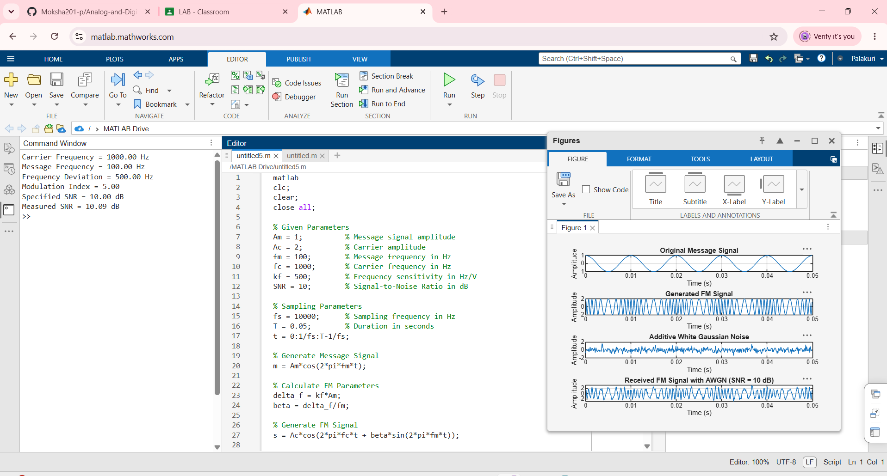
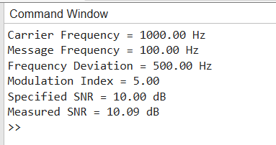

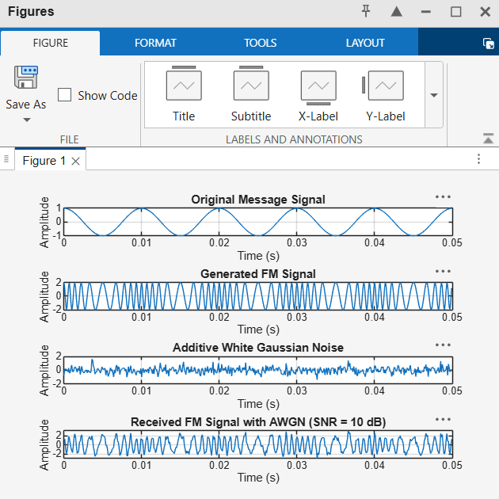

OBJECTIVE:
3. To analyze the effect of AWGN on the transmitted FM signal by comparing the original and noisy FM signals using time-domain and frequency-domain analysis.
PROGRAMMING CODE:
clc;
clear;
close all;

% Parameters
Am = 1; % Message signal amplitude
Ac = 2; % Carrier amplitude
fm = 100; % Message frequency in Hz
fc = 1000; % Carrier frequency in Hz
kf = 500; % Frequency sensitivity in Hz/V
SNR = 10; % Signal-to-noise ratio in dB

% Sampling parameters
fs = 10000;
T = 0.1;
t = 0:1/fs:T-1/fs;

% Generate message signal
m = Am*cos(2*pi*fm*t);

% Calculate FM parameters
delta_f = kf*Am;
beta = delta_f/fm;

% Generate original FM signal
s = Ac*cos(2*pi*fc*t + beta*sin(2*pi*fm*t));

% Add AWGN
Ps = mean(s.^2);
Pn = Ps/10^(SNR/10);
noise = sqrt(Pn)*randn(size(s));

% Received noisy FM signal
r = s + noise;

% Calculate measured SNR
measured_SNR = 10*log10(mean(s.^2)/mean(noise.^2));

% FFT analysis
N = length(s);
f = (0:N/2)*(fs/N);

S = fft(s);
R = fft(r);

% Single-sided amplitude spectra
S_mag = abs(S(1:N/2+1))/N;
R_mag = abs(R(1:N/2+1))/N;

S_mag(2:end-1) = 2*S_mag(2:end-1);
R_mag(2:end-1) = 2*R_mag(2:end-1);

% Display results
fprintf('Frequency Deviation = %.2f Hz\n',delta_f);
fprintf('Modulation Index = %.2f\n',beta);
fprintf('Specified SNR = %.2f dB\n',SNR);
fprintf('Measured SNR = %.2f dB\n',measured_SNR);

% Time-domain analysis
figure;

subplot(3,1,1);
plot(t,s);
title('Original FM Signal');
xlabel('Time (s)');
ylabel('Amplitude');
xlim([0 0.02]);
grid on;

subplot(3,1,2);
plot(t,r);
title('Noisy FM Signal');
xlabel('Time (s)');
ylabel('Amplitude');
xlim([0 0.02]);
grid on;

subplot(3,1,3);
plot(t,s,'b');
hold on;
plot(t,r,'r');
title('Original and Noisy FM Signal Comparison');
xlabel('Time (s)');
ylabel('Amplitude');
legend('Original FM','Noisy FM');
xlim([0 0.02]);
grid on;

% Frequency-domain analysis
figure;

subplot(2,1,1);
plot(f,S_mag);
title('Spectrum of Original FM Signal');
xlabel('Frequency (Hz)');
ylabel('Magnitude');
xlim([0 2000]);
grid on;

subplot(2,1,2);
plot(f,R_mag);
title('Spectrum of Noisy FM Signal');
xlabel('Frequency (Hz)');
ylabel('Magnitude');
xlim([0 2000]);
grid on;
OUTPUT:
